

Analysis on covid data on Databricks using Scala

* Display the files on DBFS

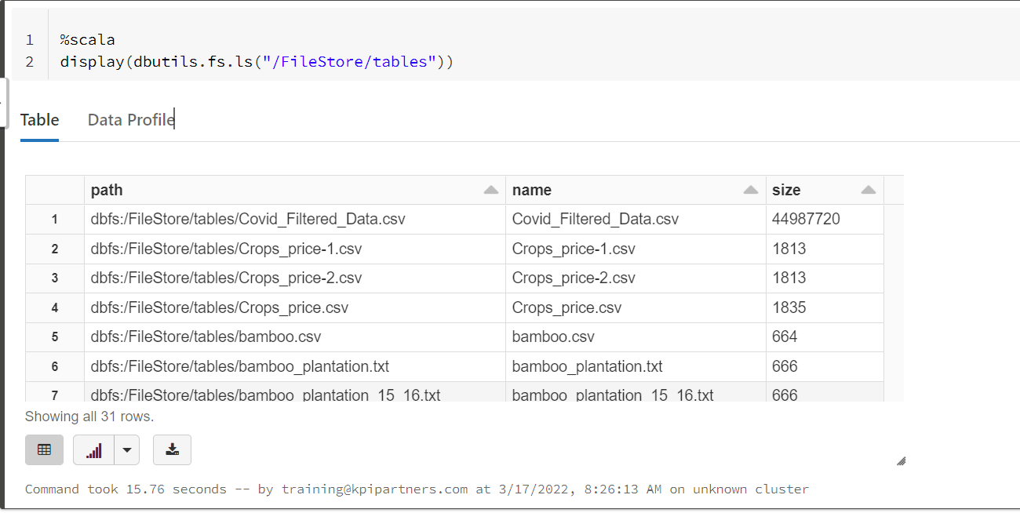

* Read the required file

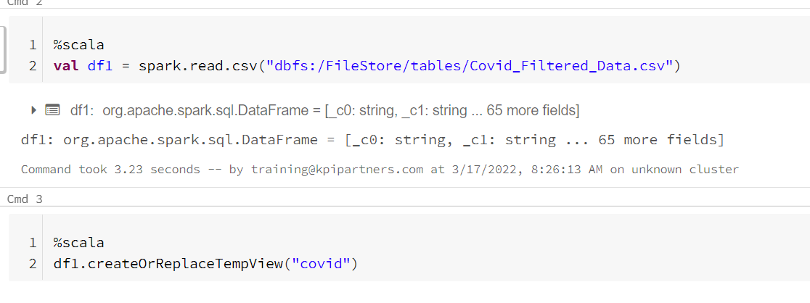

* 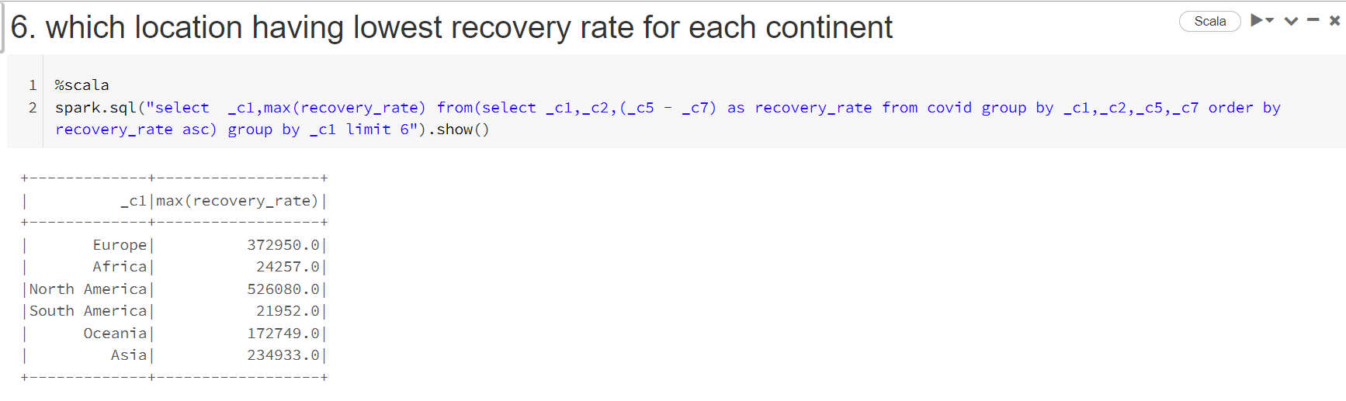which location having lowest recovery rate for each continent
* Countries with maximum cardio vascular death rate and diabetes prevalence greater than 10

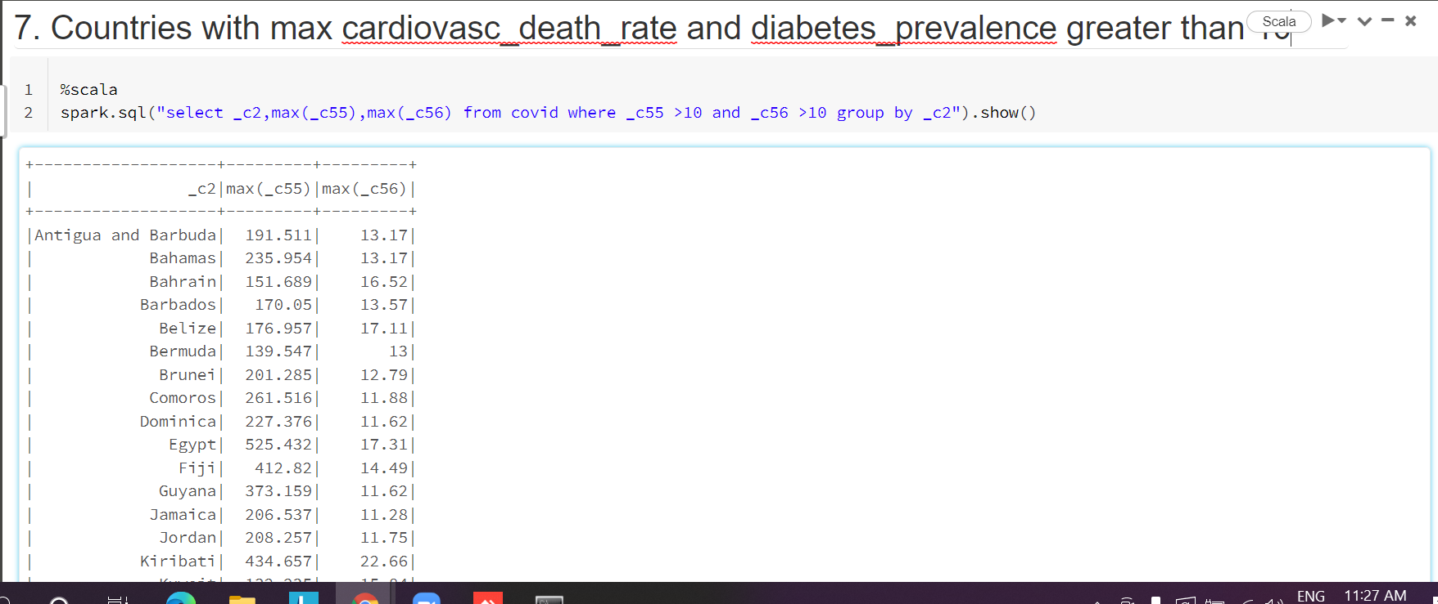

* which location has highest number of vaccinated people in each continent

